TITLE

Name:

Institution:

Instructor:

Course title:

Date of submission:

**Dividend Investing**

This type of fund management focusses on investing in stocks that are characterized as strong in terms of record earnings and dividends. This would be a perfect strategy for Wendy Jones considering her age, typical lifestyle and the liabilities she has; for instance the mortgage. This type of invest possess less risk and will suite her considering she ought to be retiring in a few years (Frank 2018). This section reasons dividend investing looking at both the advantages and limitations.

Dividend investment is guaranteed to offer a consistent payout considering the fluctuating, volatile economy that is now. With dividend investment income is continuously supplemented even on retirement. Dividend investment also possess risks and red flags. For instance an investment with very generous returns could imply an overhead decline in the company’s revenue due to the fact that they could be taking an overhead risk (Usman 2018). Dividend investment is neither a piece of cake. There are various criteria set by a company which are to be met before being considered for a dividend payout. Dividend investment is don on certain dates, this implies there are ‘ex-dividend’ days during which an investment will not be eligible for a payout.

**Dividend yield**

In contrast to other investment strategies where an increase in stock price implies an increase in the yield, dividend payout could actually decrease when a price of stock increases. Using an example of buying 100 shares @ $100. This would imply a $10000 investment. Now suppose the company Wendy buys into gives a $10 per share. This would imply Wendy would make $1000. Now if the price on stock was $200, then for the same investment Wendy will buy half the share and get half of the dividend payout. This shows that dividend investment are inversely correlated to stock prices (Frank 2018). Alternatively if the prices dropped by $10, then the investment would be worth $9000 and the dividends payout would remain $1000. This means it breaks-even with the drop, retaining the investment’s initial worth.

**Dividend assessment**

When analyzing fund management strategies we generally look whether the choice makes a good investment. Dividends are dependent on the revenue and profits made by an organization. The size of the dividend payout is an indicator of a company’s wealth. To make a strong financial portfolio a good dividend investment has to be made on an organization with a good history in terms of revenue creation, and a fair dividend payout, overly generous payouts imply risk (Usman 2018). Take the graphic comparison below of S&P and aristocrats a dividend investment of $10000in S&P 500 would have yielded $90000 on while aristocrats yields $145000.this is an instance of how company revenue and operations affect dividend (Dulin 2019).

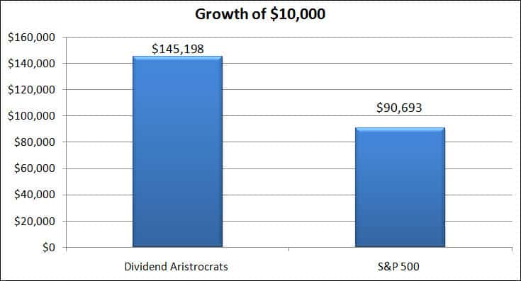

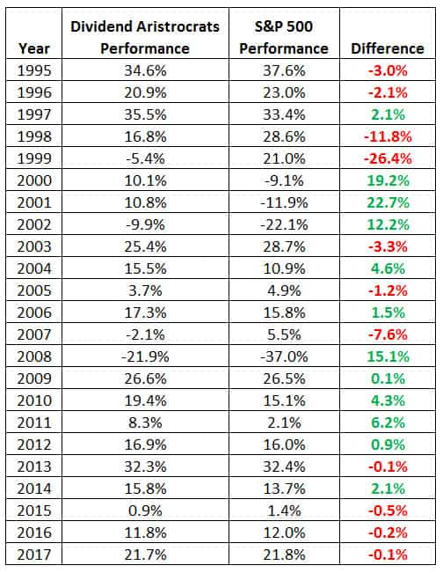

The upper hand of dividend investment is that it’s almost risk free. Dividend investment as seen above is that it actually shields drops in stocks prices. Relatively, dividend investment also creates an opportunity for increase in stock prices while retaining a constant dividend payout.

**Risks**

Like everything else dividend investment also has limitations. There are risks associated with this strategy of investment. Looking back in the 2008-2009 economic crisis (Igor 2019), many large organizations cut-off the dividend payouts to their stakeholders. This was an uncharacteristic occurrence. This implies that the dividend strategy is not a guaranteed risk free investment. The other limitation is that dividend paying companies are not high-growth oriented, it is rare to find one. Looking at the constant income payout, a dividend investment will suite Wendy.

**References**

Dulin, J. (2019) *your ultimate guide to dividend investing.* Available online: <https://www.compoundingpennies.com/ultimate-guide-dividend-investing/> [Accessed 7/18/20].

Frank, R 2018. ‘Investing the peace dividend’, *Social Policy New Orleans.* Vol 20(1) 4.

Igor, K 2019. ‘Management of investment funds: Financial fragility’, *Montenegrin journal of economics; Podgorica.* Vol 15(4) 17-32.

Usman, M 2018. ‘Investor’s behavior towards dividend paying out firms’, *Prizren social science Journal; Prizren.* Vol 2(2) 12-26.